# Meeting started at 8:30pm and ended at 10:15pm.

# People present in the 2nd meeting on Lab week 3:

Souheil Al-Awar Present

David Boivin Present

Benson ChanPresent

Annes Cherid Present

Carl Neil Cortes-Nazareth Present

Gaoshuo Cui Present

**Yassine Laaroussi Dropped**

Robert LaviolettePresent

Karim Loulou Present

Ke MaPresent

Kevin McAllister Present

Yogesh Nimbhorkar Present

# Meeting points:

* Karim and David explained us what a use case is, as well as actors and MVC.
  + MVC:
    - Model: Interacting with the data
    - View: UI
    - Control: Interaction & logic
* David showed us a draft GUI using JavaFX.
* Most of the documenters saw the Derek Bannas video of LaTex;
* Karim recommended a video for Use case: <https://www.youtube.com/watch?v=zid-MVo7M-E&feature=youtu.be>
* Kevin made a code that will auto-generate keycards, we will need to generate 10 keycards for increment 1.
* The coders and the documenters had their own groups and started talking about their tasks:
  + Coders:
    - Talked about whether we should change into an interface so we could only use one function and pass its parameters.
    - Karim & Kevin talked between them about how to implement the Controller while Yogesh and David were discussing about JavaFx GUI.
    - We use enums for card colors to reduce the classes.
    - The strategy is Randomize/Sequential strategy.
    - Also the main menu came into discussion: should it be
      * A GUI with (new game/Quit);
      * A simple toolbar (File-New Game, Options-Quit/About).
    - Use of stacks for the undo/redo function:
      * Which holds the variable and then redo to go back. We might need to set up 2 stacks.
    - Also some of the Classes will be :
      * Cards class which stores cards;
      * KeyCard will generate a random key card for the Spymaster;
      * GameBoard will have the actual game with counter of number of team members remaining and whose turn it is as well as a verbose of what the user needs to do;
      * Player, an interface with computer_player and human_player;
  + Documenters:
    - Started a sample LaTex file;
    - Definitions and diagrams were mentioned:
      * Ex of a Use Case: User->Click next->Picks Random Number->process it accordingly;
      * MVC, Use cases, Planning and LaTex were also mentioned;
    - Need to get list diagram of keycards/names from Kevin
    - The subgroup made a bullet-point list to fill out (see Annex 1);
    - They assigned what every team member has to do (see Annex 2)
    - The requirements document has already started;

# Some other things we talked about

1. In our meeting yesterday (Documenter’s 1st meeting on Tuesday 22nd Feb) we looked over both the sample latex document as the example one from iteration 2. Are there any hard guidelines to follow for this document, or is the goal simply to make an ENCS282-style-written business document (technical writing document, or whatever it's called) for the overall project that includes everything in it?
2. Robert: From my understanding, what we need from the documenters for iteration 1 is the shell of a latex document, rather than an entire written-up thing. this would include: the system requirements specification (which is just a sub-section), all of the information about all of the use cases we do (including diagrams, etc), but also the outline of everything else that's going to start going in it and diagrams for the basics (eg. some of what we discussed last night). My question is if that's a correct summary of the documentation we need.
3. Benson might not be part of our team since he changed lab times, he needs to check with the professor.
4. We are going to meet up from now on Wednesdays from 8:30pm to 10:00pm instead of 9:30pm to 11:00pm.
5. 9:45pm, Annes took the team together and talked about the Iteration due date and the Demo due date. Due date for the Increment 1 is Feb 10th and demo is Feb 7th. Made sure everybody is on the same page. We cleared out what the documenters need from the coders. We talked about JUnit and the coders will take care of it later on when the code will be ready to operate. The documenters heard how the coders plan to implement their assigned use case.

# Team subgroups:

**For Increment 1:**

**Coders:** Kevin, Karim, David & Yogesh;

**Organiser:** Annes;

**Documenters:** Souheil, Gaoshuo, Ke, Benson, Robert & Carl Neil.

Meeting ended at 10:15 PM

# Annex 1

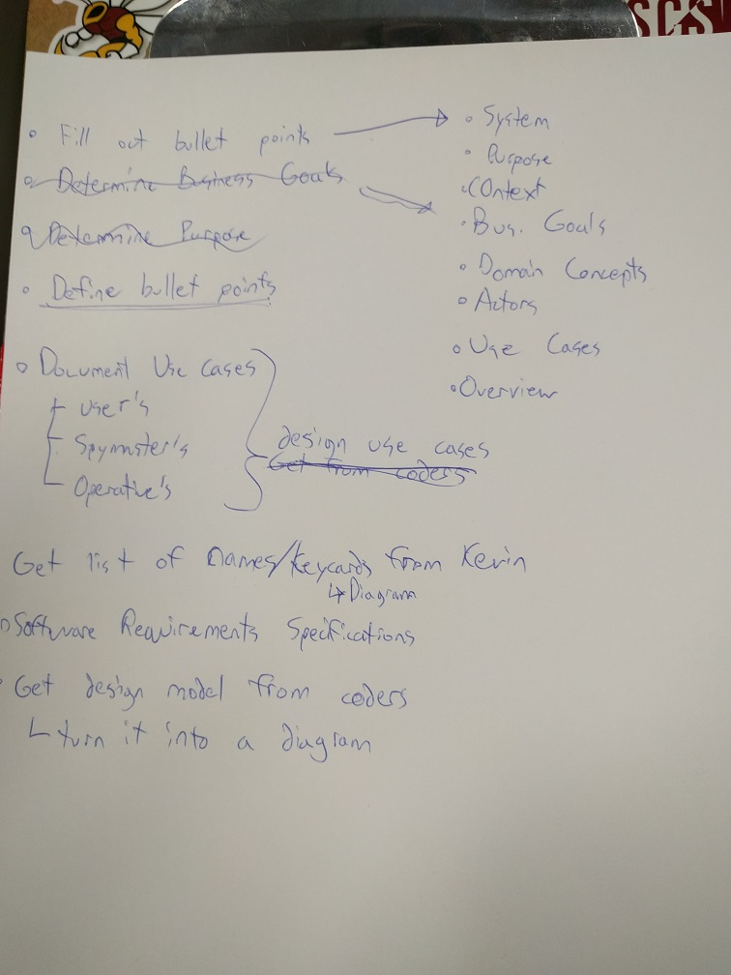

# Annex 2

